Environmental Research Summer Assignment 2023
RVGS—Mrs. Villers, jvillers@rvgs.k12.va.us

We began your summer assignment in the Spring. You signed up to be an expert on a certain article from https://www.scienceintheclassroom.org/ You will present that article and introduce yourself on the first day of elective. Please turn in the assignment to the Canvas drobox prior to the first day that elective meets or email your presentation to jvillers@rvgs.k12.va.us

Part 1: You and your interests.
Include one or two slides in your PowerPoint presentation to introduce yourself. Use the prompts below to introduce yourself to your classmates.
What are some of your favorite things to do?
What do you know about science?
How does your favorite activity relate to science?
What do you think you may learn in this course this year?
What is one thing you really like about yourself?
What kinds of jobs are there for scientists in the real world?
Where have you seen science in books, graphic novels, television, or movies?

Part 2: Paper Presentation:
You will present the article you signed up for in the Spring. You are the class expert on your article.
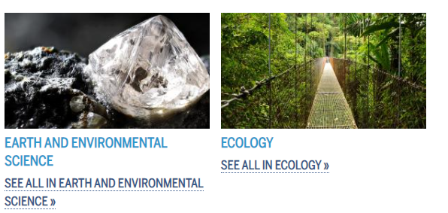
Your PowerPoint presentation should be approximately 5 minutes. The last slide in your presentation should be the APA citation of the article and any other resources you used.

I hope you all have a great summer, and if you have any questions, don’t hesitate to ask.

