AP Calculus ALC/AB Summer Assignment Instructions
To get started on your AP Calculus ALC/AB Summer Assignment, navigate to the website:
www.deltamath.com
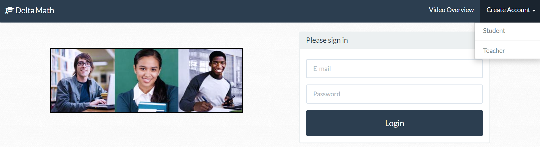
Click on “Create Account” followed by “Student”
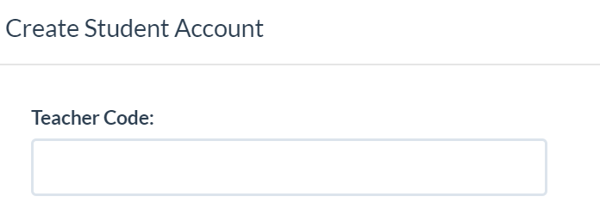
In the Teacher Code box type: 178472
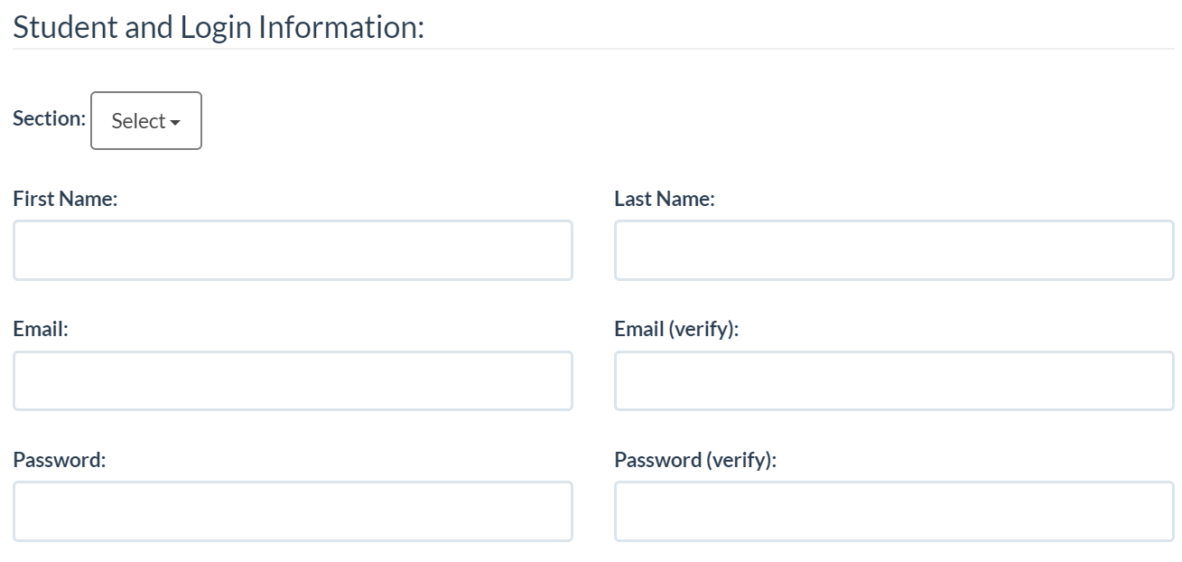
Enter your First Name, Last Name, Email address, & password, then click Create Account! You will be prompted to choose a section (please choose AM or PM, depending on when you come to Gov School and your respective course – AB or ALC).
You are ready to get started on your Summer Assignment! Good luck!

