Signing Up for Onshape & Intro Tutorials
Proceeded to the following URL https://www.onshape.com/en/
Once there click on the sign-in screen you should see the image below on the screen
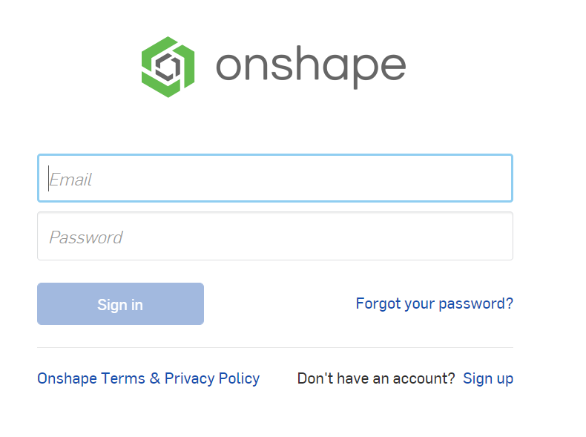
Click on the sign-up in the bottom right-hand corner and it will take you to this screen
Scroll down and click on the center box for Onshape Education where it says request your education account.

It will take you to a new page where if you scroll down you will encounter this text field
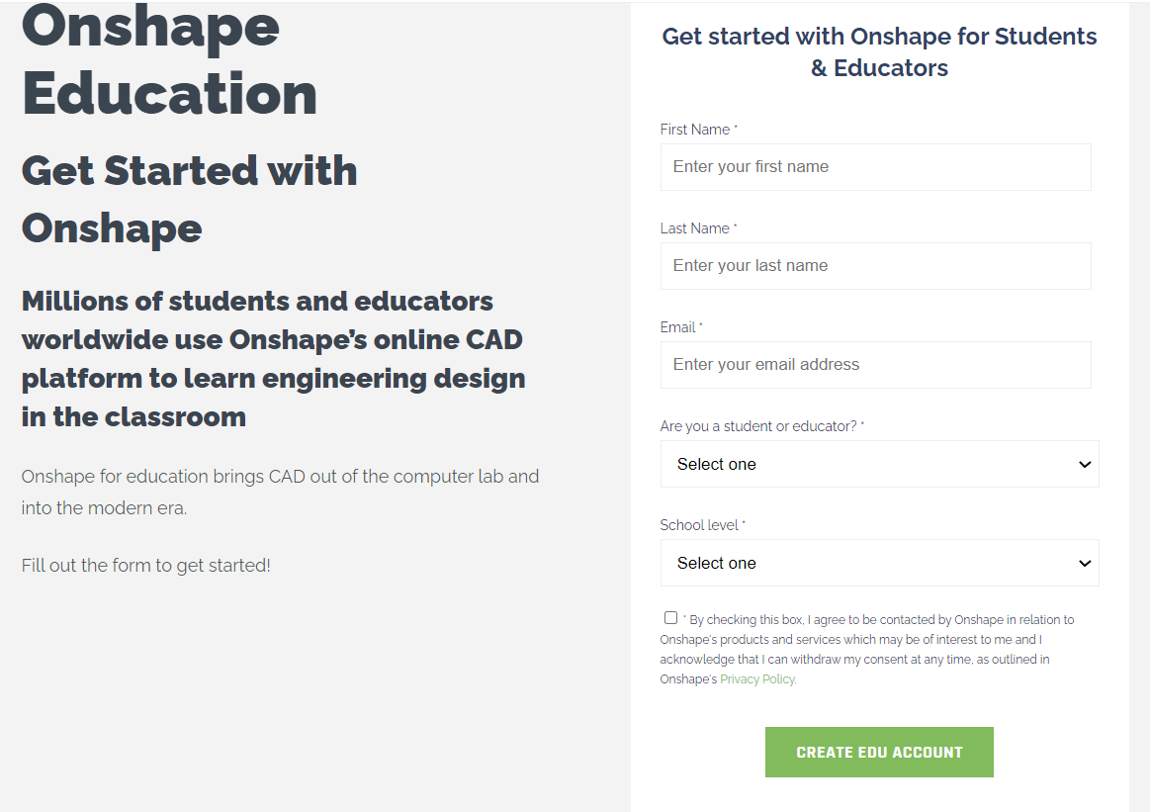
Fill this out to start creating your Onshape account.

Once your account is created and logged in, you should be presented with this screen. 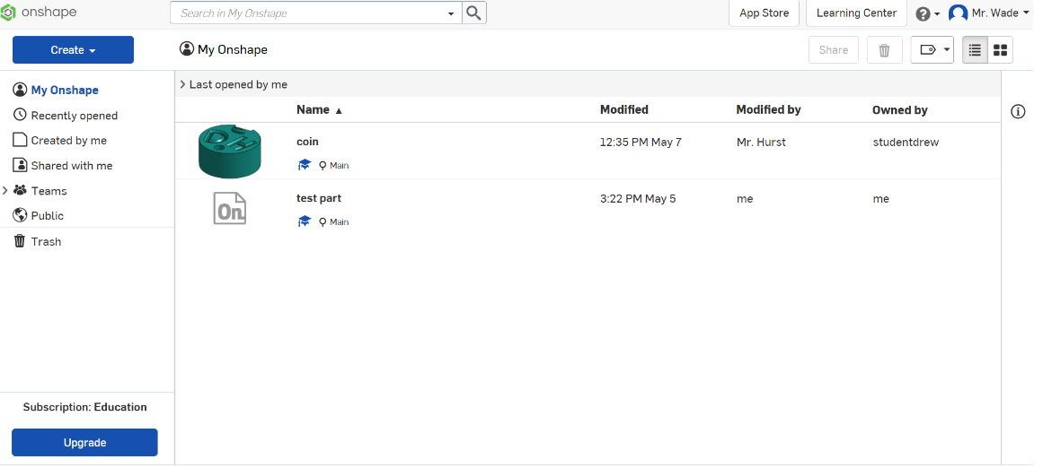
In the top right corner, there is a button that says learning center click on it. This will take you to a webpage with a number of helpful tutorials we will use to learn the basics of using Onshape.

After clicking on the learning center button at the top of this new page click on the SELF-PACED COURSES drop-down menu and select ALL SELF_PACED COURSES which will take you to yet another new page in the drop-down menus on the left side click the option for CAD Basics.
This should appear on the screen
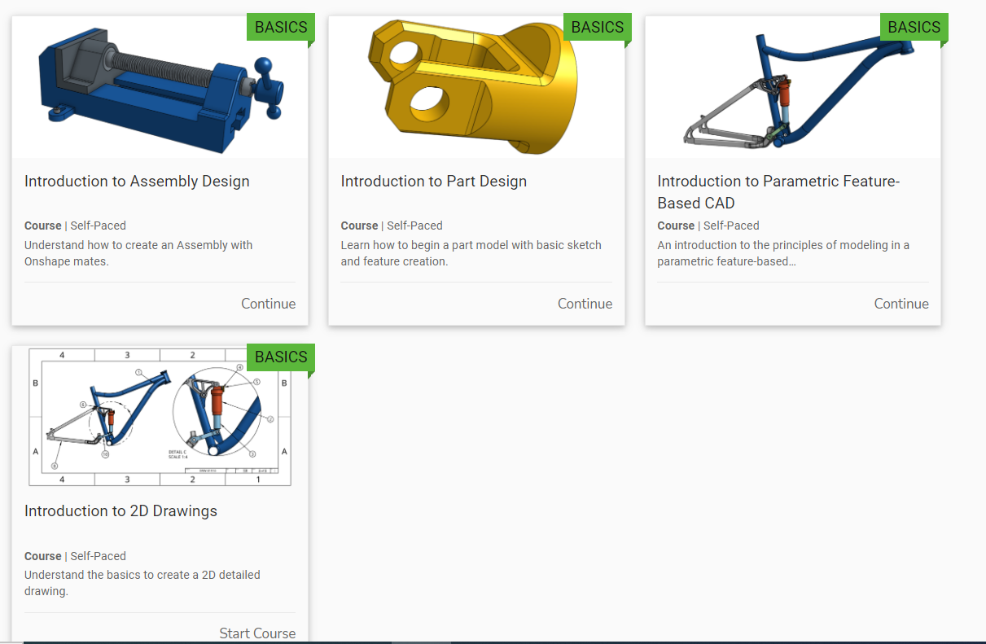

Select Introduction to Part Design and complete this tutorial. When you complete everything in this section, take a screenshot of your screen and save the screenshot, you will need it later.
Return to the CAD basics page and now complete the Introduction to Assembly Design. When you complete everything in this section, take a screenshot of your screen and save the screenshot, again you will need it later.
Again, return to the CAD basics page and now complete Introduction to 2D Drawings. When you complete everything in this section, take a screenshot of your screen and save the screenshot, you will need it later.

Last Part of Onshape Assignment
Now that you have completed some of the tutorials in Onshape, you will create your own object using your learned skills. This object can be anything. It could be you taking a physical object you have and creating it Onshape, or you can create it from scratch the choice is yours.

The requirement for this part is fairly simple. The more complex the item you create and the more of the onshape skills and features used the higher the grade for this part is. If you create something that could be recreated within 10 minutes that is not making use of the different tools that onshape has your grade will be lower.

Make sure to keep what you create somewhere easily accessible because it is due with the rest of this assignment. (I will explain how to share the object you create with me during the first class back from summer break).
When it’s due
All of this work will be due the second Engineering Class we have when we are back from summer vacation.

Other than the tutorials that are mandatory for the summer assignment doing some of the other tutorials that Onshape has to offer can help improve your skills with the program. One that I recommend would be the following which can be found with the following instructions. This is not mandatory and is not graded
Return to the ALL SELF_PACED COURSES this time on the left side click the option for ONSHAPE FUNDAMENTALS which will take you to the page shown below.
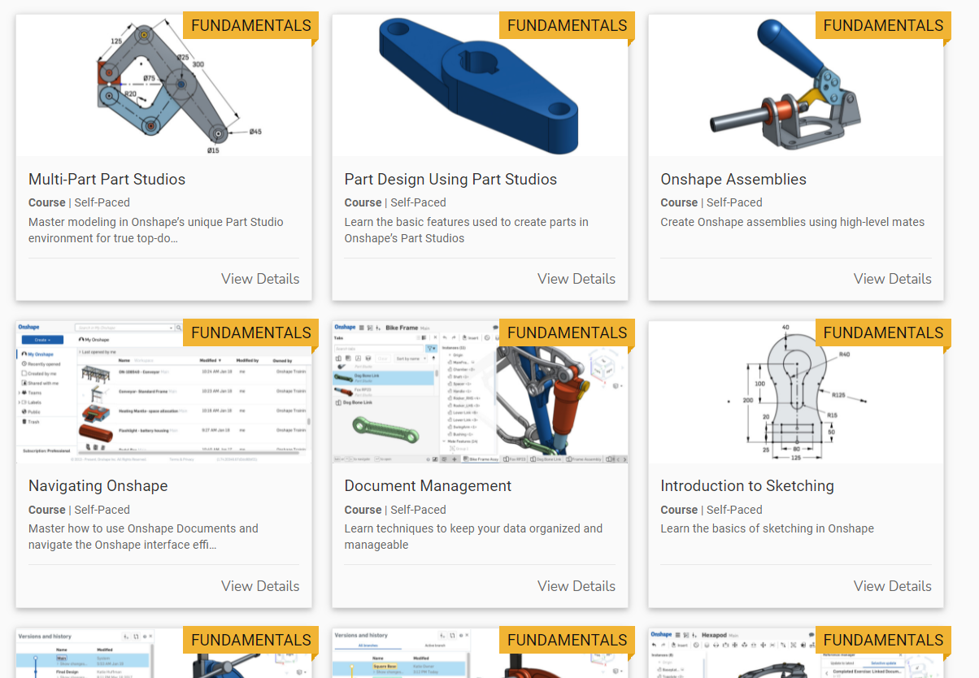
Select the one titled Part Design Using Part Studios.

Arduino Part of Summer Assignment
Paul McWhorter’s video series on Arduino https://www.youtube.com/watch?v=fJWR7dBuc18&list=PLGs0VKk2DiYw-L-RibttcvK-WBZm8WLEP
The videos for Paul McWhorter’s Arduino series that you will complete for the summer assignment are.
- Arduino Tutorial 1: Setting Up and Programming the Arduino for Absolute Beginners

- Arduino Tutorial 3: Understanding How Breadboards Work

- Arduino Tutorial 4: Understanding Arduino Variables

- Arduino Tutorial 7: Understanding the Arduino Analog Write Command

- Arduino Tutorial 9: Understanding Ohm's Law and Simple Circuit Design

- Arduino Tutorial 10: Understanding How To Read Analog Voltage using analog Read Command

- Arduino Tutorial 11: Understanding the Arduino Serial Port and Print Commands

To receive credit for these videos you will submit the code and a picture of the circuit you make for the video.

The videos listed above are the only ones that are required for the summer assignment. But just like the Onshape section of the summer assignment the other videos/tutorials he has are helpful and if you are enjoying the Arduino things you can use the other videos to learn more. The other videos Are Not Mandatory

